Introduction

This analysis focuses on predicting H1N1 vaccination rates using demographic and socioeconomic factors. The H1N1 influenza pandemic of 2009-2010 highlighted the critical importance of understanding vaccination patterns and their determinants across different population segments. This study employs advanced statistical methods, including Bayesian hierarchical modeling, to analyze factors influencing vaccination decisions and develop predictive models for vaccination likelihood.

Problem Description

The H1N1 pandemic of 2009-2010 highlighted the importance of vaccination to prevent outbreaks. This study uses data from the 2009 National H1N1 Flu Survey to predict vaccination likelihood based on demographic, behavioral, and geographic factors like education and location. Bayesian hierarchical modeling identifies key influences, such as doctor recommendations and healthcare worker status, achieving strong predictive performance (AUC of 0.82). By understanding these factors, the study aims to inform targeted public health strategies to improve vaccination rates and reduce future pandemic risks.## Data Cleaning and Imputation

Data cleaning and Imputation
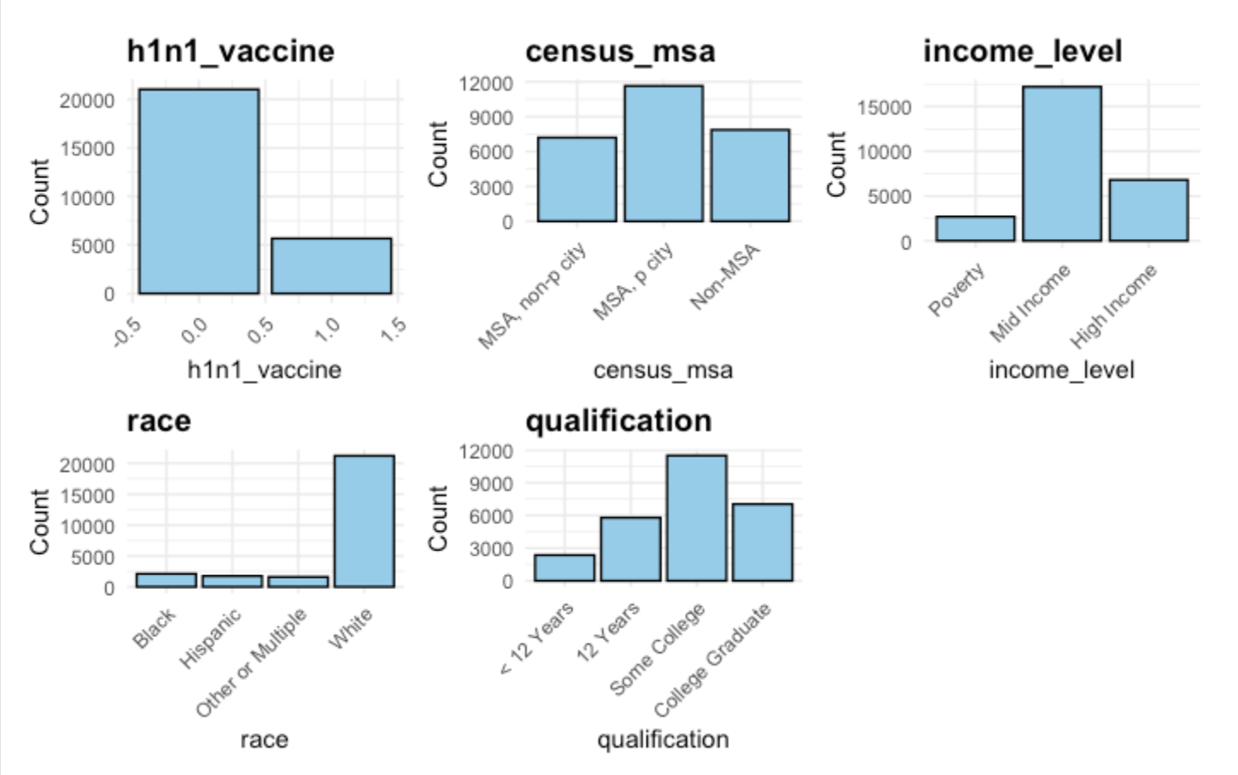
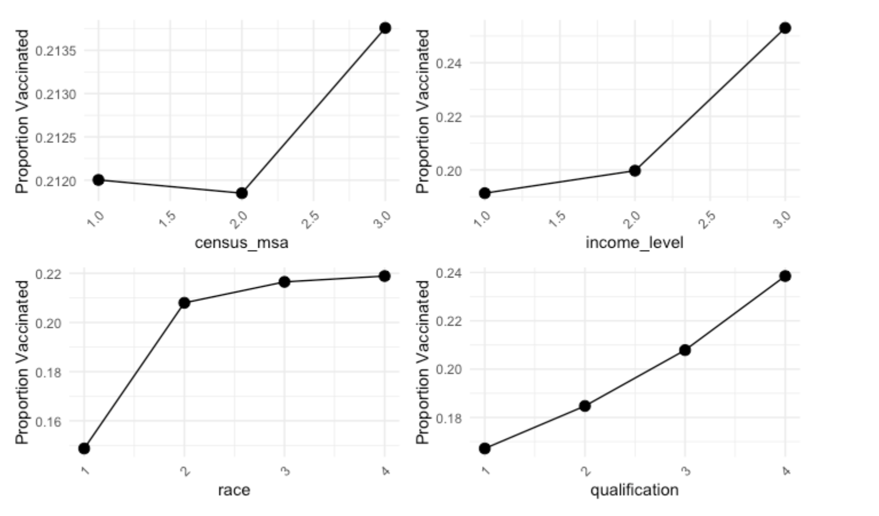
Ordinal Encoding used for variables with a natural order, like income levels, to retain their ranking structure. Factor Encoding applied to unordered categorical variables to convert them into a usable numeric format. The cleaned dataset was then split into two parts: 70% Training Set is for developing and optimizing models and 30% Testing Set is or evaluating model performance and ensuring it generalizes well to new data.

The exploratory data analysis highlights key group-level factors, such as education, geographic location, and income levels, which influence H1N1 vaccination rates. Variables like metropolitan statistical area (MSA) classification and education level can serve as group-level predictors in hierarchical models, capturing differences in vaccination behavior across these categories. For example, income disparities significantly impact vaccination rates, likely due to differences in healthcare access and awareness. These insights justify the use of hierarchical modeling to account for variability across groups and improve predictive accuracy.

